# Website Overview

Once the website is running, the user will be sent to the Home Page first. In our case the user will be the agent. Whenever the agent wants to use the system, first he/she needs to contact the supervisor to give the agent a login key, using the ID and the supervisors’ name. Than the website will output the login key together with the supervisors details and the agent than can use this key to log in to the system. Once the agent is logged in to the system, one can send and receive messages.

The mailbox only has a maximum of 25 messages. If this is exceeded, the system will log the agent out and has to log in again. Message are saved in the mailbox for 30 minutes from when they are received than they will be deleted. A message is said to be invalid when:

* The Source Agent does not match the Logged-in user
* Blocked letters such as recipe, ginger and nuclear are found in the message
* A message exceeds 140 characters
* The message limit is exceeded
* Target Agent exceeded message limit

After 10 minutes logged in to the system, the user will be logged out and has to log in again too.

# Task 1 - Unit Testing and Test Driven Development

## Test Patterns

The type of pattern used in this system is the Dependency Injection. This was used in all classes to explain to the system how it needs to accept the data. Taking the Agent Class as an example, if the sent and received messages of the agent do not exceed 25 than he may proceed to send a message only if the destination agent hasn’t exceeded the maximum messages else the message is not sent. Taking the Messaging System Class as another example, for a message to be sent, the system needs to obey certain pattern. This means that if the Source Agent Id matches the session ID and the characters in the message don’t exceed 140, than the system will try to send the message. The message will not be sent also if there are blocked letters found in the message.

## Test Doubles

### Mock Objects

Example of a mock object is Mockito. This is used in our system to verify the SUT behaviour. The object will know what behaviour to expect. If the behaviour doesn’t match with the expected one the test will fail.

## Testing strategies

### Combinatorial Testing

The type of this testing that was used was the Partitioning Strategy. This was used to test the part where the system accepts a login from an agent and take into consideration the time when the account was logged in and after 10 minutes is logged out.

## Testing Coverage

### UnitTesting Coverage

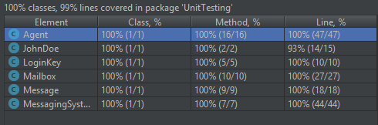

## Task 2 - Cucumber and Automated Web Testing

### Selenium

Each page in the system has a class implemented for it. These classes consists of methods to help the system determine what need to be done when the agent clicks a certain button or when data is entered. Servlets were used to connect with the JSP

### Cucumber

* Scenario 1: Successful Login

When an agent tries to log in, first the agent needs to contact the supervisor for a login key. When the key is obtained, then the agent will be able to log in using a valid ID and the login key given by the supervisor.

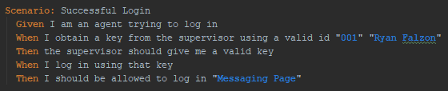

* Scenario 2: Login timeout

When an agent tries to log in, first the agent needs to contact the supervisor for a login key. When the key is obtained, then the agent will be able to log in using a valid ID and the login key given by the supervisor. If the agent fails to login within 65 seconds, he/she will not be able to log in.

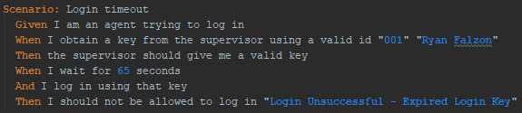

* Scenario 3: Surpassing message limit

An agent is already logged in and when he/she tries to send 25 messages, all messages should be sent successfully. Than when the agent retry to send another message the system will give you an error as the agent has exceeded the limit and he will be locked out.

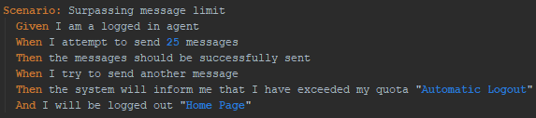

* Scenario 4: Blocked words

When an agent is already to log in to the system and sends a message to another agent, the target agent should receive the message.

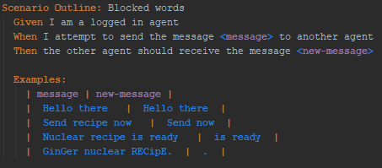

* Scenario 5: Logging out

When an agent is logged in and clicks log out than the agent will be logged out and the system will take you to the Home Page.

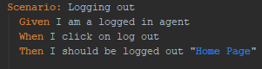

## Task 3 - Model-Based Testing

We designed a Finite State Diagram and then implemented it in classes for the system to work using model-based testing.

## Task 4 - Performance Testing